More HTML Problems

## **Images**

1. For the following question, assume the image is 1000 pixels wide and 800 pixels high. Indicate the values needed in the following HTML to produce an image with an aspect ratio of 2:1 while maintaining the image's width of 1000 pixels.

<**img** alt="A sleepy dog"

src="https://resources.zybooks.com/WebProgramming/mediumDogv1.jpg"

width="(a)" height="(b)">

1. ________________

(b) ________________

1. **Valid or invalid?** <**img** src="smiley.gif">
2. **Valid or invalid?** <**img** src="sparky.png" alt="Picture of my dog, Sparky"></**img>**
3. **Valid or invalid?** <**img** alt="Fun weekend" src="weekend.jpg">

## **Tables**

1. Make the table:

## **Hyperlinks**

What do each of the following hyperlinks do?

1. <a href="https://example.com/index.html">See example</a>
   1. Loads a web page over an unencrypted connection
   2. Encrypts the web page load request and response
   3. Sends an email
   4. Opens a file on same computer as browser
   5. Transfers data files between server and browser
2. <a href="mailto:person@example.com">Get in touch</a>
3. Loads a web page over an unencrypted connection
4. Encrypts the web page load request and response
5. Sends an email
6. Opens a file on same computer as browser
7. Transfers data files between server and browser
8. <a href="file:///Users/username/labs/bistro.html">Bistro menu</a>
9. Loads a web page over an unencrypted connection
10. Encrypts the web page load request and response
11. Sends an email
12. Opens a file on same computer as browser
13. Transfers data files between server and browser
14. <a href="http://example.com/index.html">See example</a>
15. Loads a web page over an unencrypted connection
16. Encrypts the web page load request and response
17. Sends an email
18. Opens a file on same computer as browser
19. Transfers data files between server and browser
20. <a href="ftp://example.com/index.html">Raw data</a>
    1. Loads a web page over an unencrypted connection
    2. Encrypts the web page load request and response
    3. Sends an email
    4. Opens a file on same computer as browser
    5. Transfers data files between server and browser
21. **True or false?** Hyperlinks may only contain text.
22. **True or false?** The fragment identifier for the <p id="location"> opening tag is location.
23. **True or false?** Two tags within the same HTML document may have the same id.
24. **Valid or invalid?** <a href="example.com/index.html">See example</a>
25. **Valid or invalid?** <a href="https://example.com/index.html#History"> History</a>
26. **Valid or invalid?** <a href="#History">History</a>
27. **Valid or invalid?** <a href="course.html#Notes">Notes</a>
28. **Valid or invalid?** <a href="https://example.org/index.html"> <img src="https://example.org/picture.jpg"></a>
29. **Valid or invalid?** <a href="file:///Users/example/index.html">Another example</a>

## **Container tags**

Use the following visible containers created with the provided HTML below to answer the questions.

<**body**>

<header>

<**h1**>The White House</**h1**>

</header>

<section>

<**p**>

The White House is the official residence of the

President of the United States.

</**p**>

<**img** src="WhiteHouse.jpeg" alt="Picture of the White House">

<**address**>

White House<**br**>

1600 Pennsylvania Avenue Northwest<**br**>

Washington, DC 20500

</**address**>

</section>

</**body**>

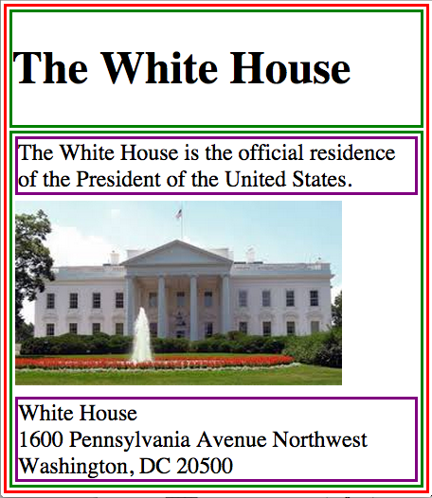

1. Which tag creates the container that holds the entire web page?
2. Which tag creates the container that holds the picture?
3. Which tag creates the container that holds the White House address?
4. Which tag creates the parent container that holds the paragraph's container?

## **Forms**

1. Match each <input> attribute to the corresponding effect.

* placeholder
* type
* id
* name
* value

Indicates which kind of widget is displayed by the browser.

Allows the server to identify which data came from which widget.

Uniquely identifies the specific input tag to the browser.

Allows the input to start with a default value.

Provides a hint to the user about the information being requested.

1. Which tag creates a text box widget?
2. <input>
3. <text>
4. <textarea>
5. Which attribute must be set to create a text box widget?
6. type
7. no attribute
8. name
9. id
10. Which tag creates a text area widget?
11. <input>
12. <text>
13. <textarea>
14. Which attribute inside the <label> tag is used to associate the label with a widget?
15. id
16. for
17. name
18. Refer to the HTML below.

<**form** action="https://google.com/">

</**form**>

To which server will the browser send the form data?

Which method will the browser use to communicate with the server?